Marko Smiljanic

CSc 165 Assignment 1

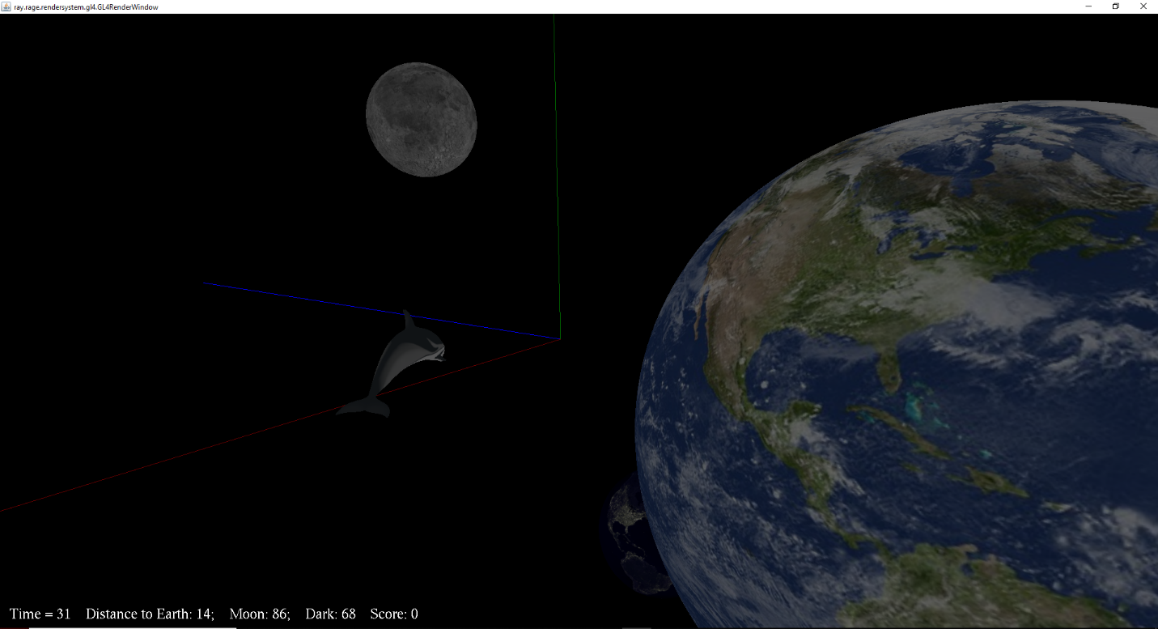

**How to Compile and Run:**

Included in the assignment folder are two batch files, compile and run. Double click compile.bat to compile and generate all the necessary class files. After compiling has finished, double click run.bat to run the game. The same compiling can be done by opening a powershell window in the Assignment 1 folder. From there, first type “javac a1\*.java” and hit enter. Once the compiling is done, type in “java -Dsun.java2d.d3d=false a1.MyGame” and hit enter. These two options will run the game.

**How the Game is Played:**

The objective of the game is to collect the three evil hearts of the planets. Your dolphin will travel very fast and you cannot move too far from it. Your dolphin will not enter the planets however, so you must get off the dolphin to travel in to collect the planet’s heart. Collect all three and you have finished the game.

**Inputs:**

**(Keyboard Controls)**

W – Move Forward, A – Move Left, S – Move Back,

D – Move Right, Left – Yaw Left, Down – Pitch Down,

Right – Yaw Right, Up – Pitch Up, Q – Roll Left, E – Roll Right Space – Hop On/Off the Dolphin

**(Controller Controls)**

X-axis - Move Left and Right, Y-axis – Move Up and Down,

RX-axis – Yaw Left and Right, RY-axis – Pitch Up and Down

**Additional Game Activity:**

My additional activity is the collection of the world hearts. These objects lie at the center of the planets and they disappear upon being picked up and add to your score.

**Additional Game Object:**

My additional game object is the diamond used to represent the world heart. This diamond is a manually created object.

**Unfinished Requirements:**

I do not believe that I have missed any game requirements.

**Special Additions:**

I have added the ability to roll on the keyboard by using the Q/E keys on the keyboard. This is not an original requirement of the assignment.

**Assets:**

**(Objects)**

DolphinHighPoly.obj, Earth.obj – Provided with School Materials

**(Textures)**

Dolphin_HighPolyUV.jpeg, moon.jpeg, earth-day.jpeg, earth-night.jpeg – Provided with school materials

bright-blue.jpeg, bright-green.jpeg, bright-red.jpeg – Provided by professor